Estimating Staffing Needs:

You can use the following calculation to estimate the number of teams needed for the assessment activities:
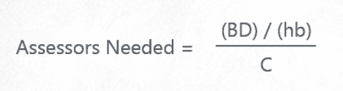
B = number of buildings in the area. Estimate based on average number of buildings per block or use the information in the report from the local Planning Department for a more accurate number.
D = percentage of buildings damaged (estimate) Estimate based on windshield assessment and other information from the field.
h = Number of working hours in a day. Usually calculated at a 6.
b = Number of buildings assessed per hour. Usually estimated at 3 – 4 buildings per hour depending on the experience of the assessment teams.
C = number of days to complete the assessments

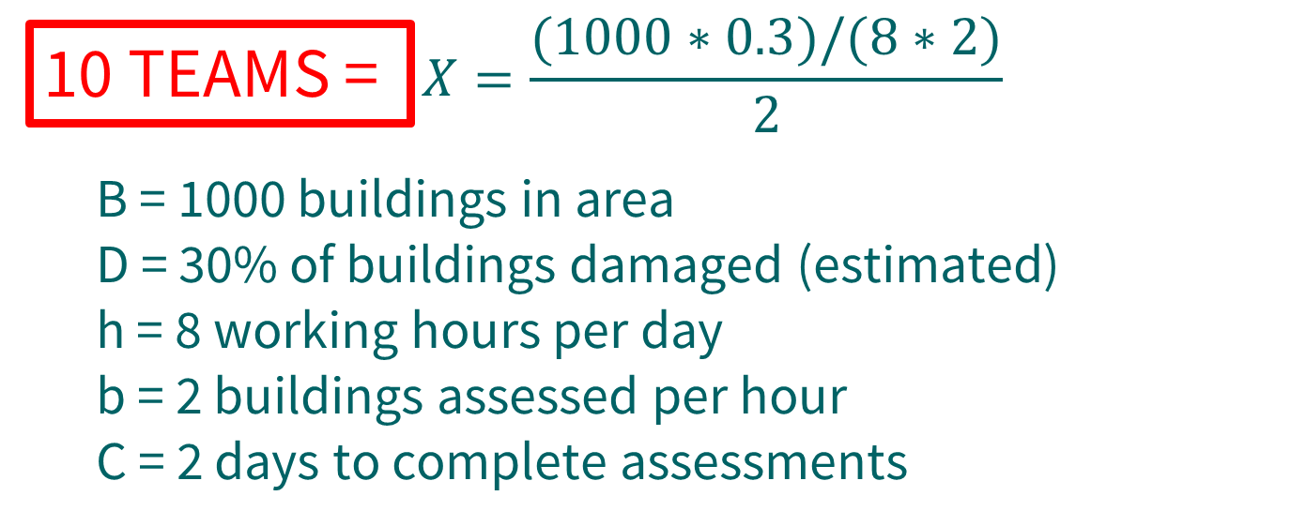

Use this calculation tool as a guide. Each incident might include other factors that must be considered when determining the number of teams. For example. The distance between buildings in a rural setting, the weather conditions, or difficult terrain might extend the average completion time.

Double Click on the formula below to access the staffing needs calculator.

