Appendix C – Identified Region(s) and Community(ies)

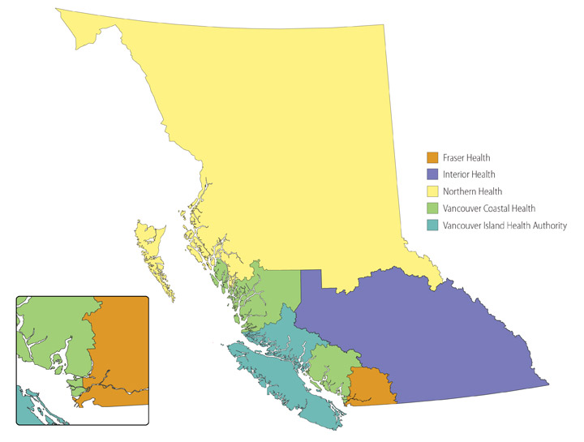

☐ Vancouver Coastal – all communities
☐ Specific communities only:
List communities here.
☐ Fraser Valley – all communities
☐ Specific communities only:
List communities here.
☐ Vancouver Island – all communities
☐ Specific communities only:
List communities here.
☐ Interior – all communities
☐ Specific communities only:
List communities here.
☐ North – all communities
☐ Specific communities only:
List communities here.

Signature of Respondent Representative
(Insert signature image)
Name and Title
Date: Enter a date.

